activeTAPI-DyNav v2018

Getting Started Manual

|  |  |
| --- | --- |
| Author: | Markus Schmidt  [msc@activeTAPI.NET](mailto:msc@activeTAPI.NET) Schmidt e-Services GmbH Wiesentalstrasse 10a D-65207 Wiesbaden |
| Last Major Update: | 20th of January 2018 |
| Revision: | 2018.00 |
| Relates to: | activeTAPI-DyNav v2018 |
| For NAV Version: | NAV 2018 |
| Last Print Date: | 20.1.2018 |
| Pages: | 13 |

Table of Contents

activeTAPI-DyNav v2018 1

Getting Started Manual 1

Table of Contents 2

1. Introduction 3

1.1. Basic Installation 3

1.2. Check Windows-TAPI connectivity 5

1.3. Troubleshooting Windows-TAPI 6

2. Getting started with Microsoft Dynamics NAV 7

2.1. Installation 7

3. RT Client Setup 8

3.1. Register RTC Add-In (no longer needed) 8

3.2. Define Start Page (no longer needed) 8

4. Configure NAV for activeTAPI 9

4.1. Test the installation and the setup 11

4.2. Troubleshooting activeTAPI.COM-DyNav 12

# Introduction

activeTAPI-DyNav consists of three parts

* **activeTAPI.COM-Objects**The bridge between Windows TAPI and Microsoft Dynamics NAV. This part includes the activeTAPI-Dialer, the Troubleshooter and the Tracing functionality.  
  Once this part works as expected you can continue with the next part.
* **activeTAPI-DyNav NAV-Objects**The activeTAPI CTI functionality within NAV. This includes the complete implementation for RT-Client and the configuration of Telephony with NAV. Consider all these objects to be examples and feel free to modify these objects to suit your needs. However, some additional ‘goodies’ – e.g. an Add-In – have to be registered in NAV for the RT-Client.

Before we get started with activeTAPI-DyNav v2018 for the Role Tailored Client (RTC) some initialization is needed.

## Basic Installation

Start with the installation of activeTAPI-DyNav:

* Download the current **activeTAPI-DyNav v2018** version from here:  
  <http://www.activeTAPI.net>   
  and run the Setup!

The basic installation installs the activeTAPI.COM-Objects and it saves the NAV-Objects to the application folder. After the basic installation you are ready to test the TAPI connectivity. There is no need yet to do anything with NAV!

### Verify the installation

In Windows 7 open the Start-Menu as shown in *Picture 1[1]*

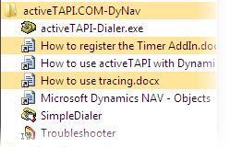

1. activeTAPI-DyNav Start-Menu entries

After installing activeTAPI you will find the configuration files here:

*%ProgramData%\Schmidt e-Services GmbH\activeTAPI.COM*

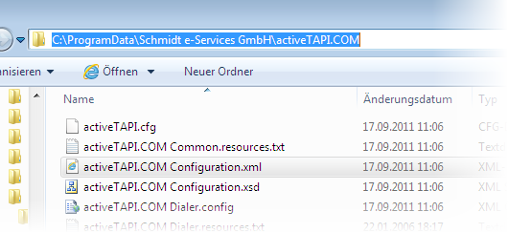

1. activeTAPI configuration files are located in the machine data folder

**Important:** Do not change anything here until otherwise mentioned!

## Check Windows-TAPI connectivity

Before you start with Microsoft Dynamics NAV make sure your Windows TAPI is configured and that it works properly.

Before you start make sure you have:

**CLOSED ALL APPLICATIONS THAT USE WINDOWS TAPI!**

Then

* Start the activeTAPI *SimpleDialer*

Check that you can dial and you receive inbound telephone numbers.

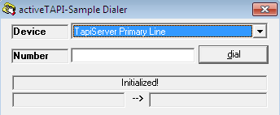

1. The activeTAPI-SimpleDialer can be used to verify Windows TAPI works properly

Select a device (see Picture 4), enter a telephone number and dial. If successful, call the telephone number that is “attached” to your machine. You should see the calling number (see Picture 5).

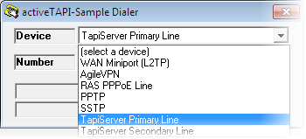

1. SimpleDialer select a device

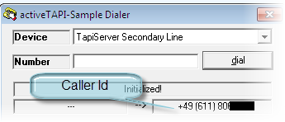

1. SimpleDialer shows incoming caller Ids

If outbound dialing work and if you can see inbound telephone numbers your Windows-TAPI is fine so far and you can continue with the Microsoft Dynamics NAV integration.

## Troubleshooting Windows-TAPI

### Check Windows Telephony

Check that you *Telephone & Modem Option* in the Windows *Control Panel* are set correctly. This includes the current location settings and the areacode of the current location.

### activeTAPI Trace Files

Using the Windows Explorer navigate to your *%AppData%* folder:

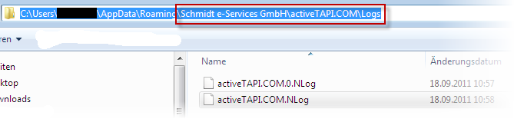

1. The %AppData% folder contains the activeTAPI logfiles.

Open the *NLog-file* with any text editor and check the logs.

### activeTAPI does not handle the leading dialing prefix correctly

Without going into details: the PBX, the TSP (Telephony Service Provider) or the TAPI routing software must not send a leading dialing prefix (like ‘0’) to the client. If it does anyway, this is a configuration error in the underlying software. This is not an activeTAPI issue!

**Important:** The leading dialing prefix has just one purpose: it is used to tell the local PBX that you want to get a line for outbound dialing. Such a prefix is never part of a telephone number and it should neither be stored in any database not should it be added to telephone number before you dial.

### You don’t see an inbound number

There are some situations where you don’t see inbound numbers. In any case, it is **not** a problem of activeTAPI if you don’t see it! Either you TSP does not route the numbers correctly, there is another application “catching” the numbers and/or you have a buggy TSP. The latter one is the most common error. Check your PBX Vendors Web-Site to get an up-to-date TSP for your device!

Also, some TSPs do not support more than one application listening to incoming calls. Thus, if you have one application open – for example a Dialer that was shipped with the TSP – in some cases this Dialer will then get the incoming call events and activeTAPI will not receive anything. Again, this is a problem of the TSP! As a workaround you should close all applications and check if you can then see incoming calls in the SampleDialer.

### Check if activeTAPI.exe is running

Whenever something does not work as expected check if there’s an active process called *activeTAPI.EXE.* This process must not exist when all activeTAPI applications have been closed: RT-Client, activeTAPI.COM-Dialer, SampleDialer, etc.

If *activeTAPI.exe* is running anyway you can safely shutdown this process using the Windows Task Manager.

# Getting started with Microsoft Dynamics NAV

After you have made sure your telephony works as expected it is now time to integrate telephony with Microsoft Dynamics NAV.

**Important:** The NAV Objects can be used for **Microsoft Dynamics NAV 2018, only**!

If you use still older version of NAV, contact us.

## Installation

* Open Microsoft Dynamics NAV Development Environment
* Navigate to the Object Designer
* Import the activeTAPI FOBs from the %ProgramFiles%\activeTAPI.COM folder



Import activeTAPI FOBs

**Important:** The filename of the objects depend on the current version of activeTAPI-DyNav. For example: v2018 stands for v2018 release.

RTM means first version (Build 19394). For cumulative Updates the version will include the number of the update, f.e.: AT-v2018-CU01-new-objects.fob.

All the activeTAPI objects contain version code *AT:*

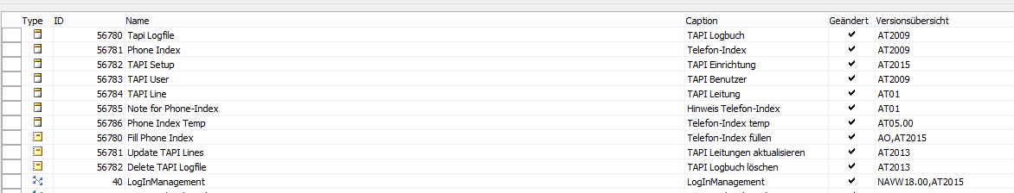

1. Imported activeTAPI Objects for Role Tailored Client

# RT Client Setup

Although activeTAPI-DyNav is a 32-bit application, you can use together with the 32—and the 64-bit Navision Client (because even the 32-bit-Client is a 64-bit-client. Funny !).

activeTAPI-DyNav comes with an Add-In for the Role Tailored Client. This Add-In is used on Page 56785 *Page with Timer* to work around the RTC’s disability to receive local events.

The *Page with Timer* acts as the telephony event receiver (bridge to CTI) in the RTC. Without having this page opened the RTC won’t receive CTI notifications.

## Register RTC Add-In (no longer needed)

Registering of the RTC Timer AddIn is no longer needed, because we use the PingPong-Addin as Timer.

But please take care: If you want to use PingPong-Addin yourself, this is not possible, because there can only be one PingPing in a database.

## Define Start Page (no longer needed)

In older versions of activeTAPI-DyNav the Start Page 56785 was started in the properties of the desktop icon for the RT Client (**"DynamicsNAV://///RunPage?Page=56785").**

**In** activeTAPI-DyNav v2018 the page is started inside of NAV (Trigger “LoginStart” in Codeunit 40). It will only start, if

* TAPI Setup exists
* TAPISetup “Runs in developer mode” is set to false (default)
* TAPI Setup “TAPI Line name” is defined
* For the actual User “Use activeTAPI” is true.

This page must always run (in background), because it is the heart of the event-handling for the RT Client. Therefore you get a warning, if you want to close this page (or the client).

Now, restart the NAV Client and check that activeTAPI is loaded and initialized properly (see Picture 10)

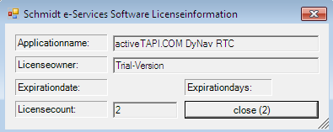

1. activeTAPI License Dialog

Please notice that the license dialog does not appear anymore when you have a purchased license!

# Configure NAV for activeTAPI

Navigate to the Telephony Configuration (you find it in Departments):

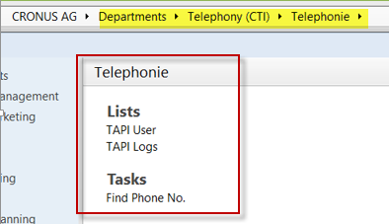

Update the TAPI Lines:

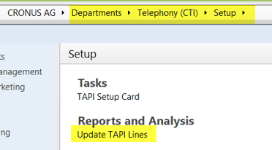

This is the first and simplest test to examine whether the automation objects were installed correctly or not.

### Menu "Telephony (CTI)", "Setup", "TAPI Setup"

1. Length of internal phone no.: Enter a number, e.g. 2
2. Action for incoming call: e.g. "Show menu"
3. Create call data: No
4. TAPI Line Name; select it; if no line is available, step 7.A did not run correctly
5. Min. length for PhoneIndex: , e.g. 4
6. Format Phone Numbers: Yes
7. Format Fax Numbers: Yes
8. Check of double numbers: Possibility to avoid duplicates
9. Create Interaction Log Entry: Yes / No
10. Log internal calls: Yes / No

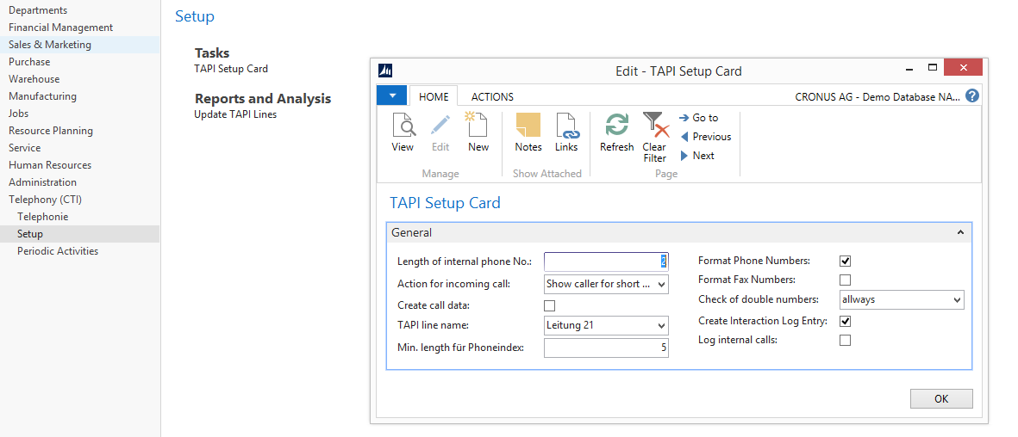

1. activeTAPI Telephony setup

### Menu "Administration", "Application Setup", "Users", "User Setup"

Activate field “Use activeTAPI” for the current user.

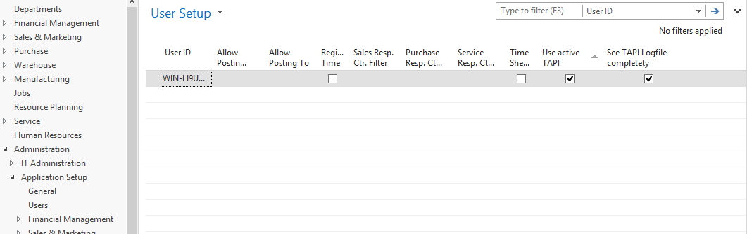

### “Departments”, "Telephony (CTI)", “Telephonie”, TAPI User"

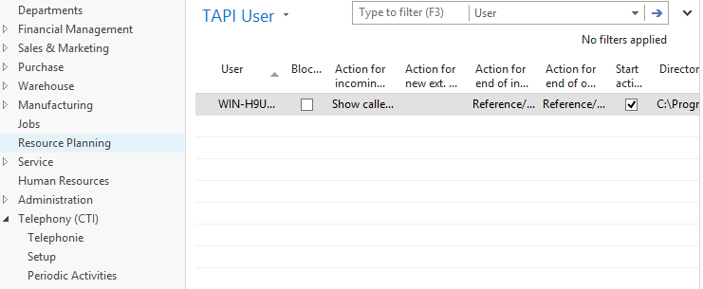

* Action for incoming call: E.g. "Show menu"
* Action for new ext. Telephone number: E.g. "Show menu"
* Start activeTAPI-Dialer: Yes
* Path of the Dialer: Select; with standard installation:  
  %ProgramFiles(x86)%\activeTAPI\activeTAPI-Dialer.EXE
* TAPI Line Name: Select a TAPI for the current user (see “Check Windows-TAPI”)

### Close and restart Navision

After this start the activeTAPI-Dialer should appear with the license information.

## Test the installation and the setup

### First outgoing call

Choose any customer, vendor or contact. Remove the Phone No. (if existing) and input a “real” telephone number (this is necessary to register it in the Phone Index). Press the telephone Bitmap button.  
After finishing the call, look into the TAPI Log (“Department”, “Telephony (CTI)”, “Telephonie”, "TAPI Logs").

### First incoming call

Choose any customer, vendor or contact. Delete the Phone No. (if existing) and input your Mobile Phone No. Call yourself with the Mobile Phone.  
After finishing the call, look into the TAPI Log (“Department”, “Telephony (CTI)”, “Telephonie”, "TAPI Logs").

### Create and check the Phone Index

NOTE: In a Standard-Navision-Demo-Database (Cronus) there are no telephone numbers. BEFORE the following activities enter some “real” telephone numbers, which can be actually called (Mobile, private, company, etc..) or from which a call can come.  
Select "Fill Phone Index" in the menu " Telephony (CTI)", "Periodic activities" and let the report run.  
Examine the error messages in the menu " Telephony (CTI)", "Periodic activities", "Notes for Phone Index".  
Check the Phone Index: Menu " Telephony (CTI)", "Periodic activities", "Modify Phone Index".

## Troubleshooting activeTAPI.COM-DyNav

Whenever you get messages like show in Picture 12 activeTAPI was not installed properly:

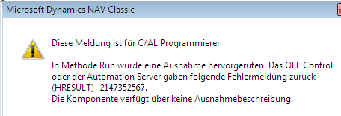

1. activeTAPI is not installed properly, Windows-COM has some invalid references in the Registry

In that case we suggest to run an Registry Cleaner to clean up the Windows Registry. This is a known issue with Windows-COM.

1. In Windows 8 search for activeTAPI.COM-Dialer.exe